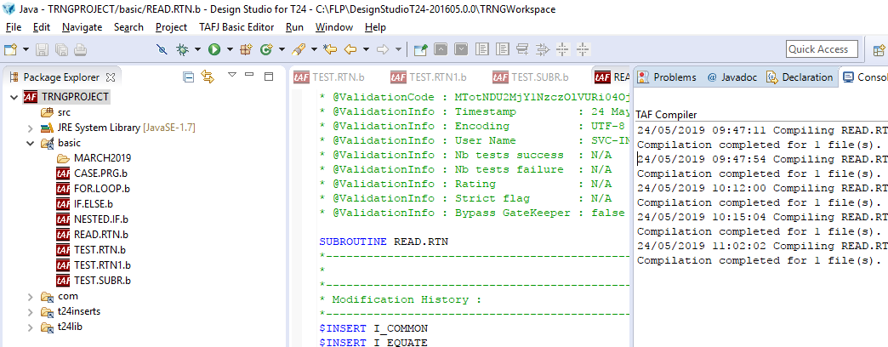

After compiling the above routine in Design studio. Go to the below path to get the corresponding class file in your local system TAFJ

C:\FLP\TAFJ\data\tafj\classes\com\temenos\t24

Copy the class file from above folder in the system.

Go to the following path in R17MB server folder

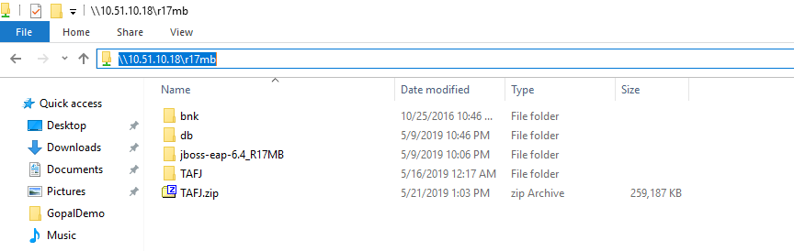

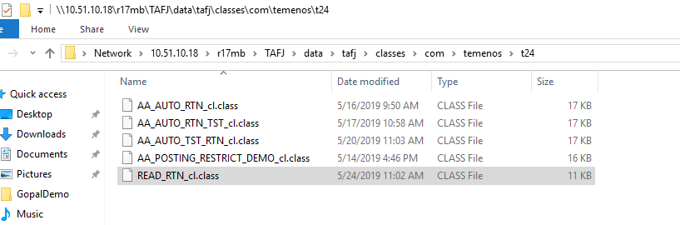

Copy the class file to the above folder.

Now you can see the tshow

